**32 РАБОТА С SQLDATAADAPTER И DATASET**

Задание 1. Изучите главу 4 пункт 4.4, используя приложение из задания №1/ Свяжите данные с помощью DataSet, предварительно создайте DataTable для каждой из таблиц БД.

Листинг программы:

public partial class Form1 : Form

{

public SqlConnection sqlConnection = null;

private SqlCommandBuilder sqlBuilder = null;

private SqlDataAdapter sqlDataAdapter = null;

private DataSet dataSet = null;

private string dbPath =

@"D:\Git projects\C-practice\day33\Day33\Task\DBTur_firm.mdf";

public Form1()

{

InitializeComponent();

}

private void Form1_Load(object sender, EventArgs e)

{

this.сезоныTableAdapter.Fill(this.dBTur_firmDataSet6.Сезоны);

this.путевкиTableAdapter.Fill(this.dBTur_firmDataSet5.Путевки);

this.оплатаTableAdapter.Fill(this.dBTur_firmDataSet4.Оплата);

this.турыTableAdapter.Fill(this.dBTur_firmDataSet1.Туры);

this.туристыTableAdapter.Fill(this.dBTur_firmDataSet2.Туристы);

sqlConnection = new SqlConnection($@"Data Source=(LocalDB)\MSSQLLocalDB;AttachDbFilename={pathToDB};");

sqlConnection.Open(); }

private void toolStripLabel1_Click(object sender, EventArgs e)

{

editTableForm editTableForm = new editTableForm();

editTableForm.connection = sqlConnection;

editTableForm.ShowDialog();

}

private void toolStripLabel2_Click(object sender, EventArgs e)

{

var currentCeil = dataGridView1.SelectedCells;

var id = dataGridView1[0, currentCeil[0].RowIndex].Value;

string query = "DELETE FROM Туры "

+ $"WHERE Код_тура = {id}";

SqlCommand cmd = new SqlCommand(query, sqlConnection);

cmd.ExecuteNonQuery();

}

private void toolStripLabel3_Click(object sender, EventArgs e)

{

editTableForm editTableForm = new editTableForm();

editTableForm.connection = sqlConnection;

var currentCeil = dataGridView2.SelectedCells;

editTableForm.textBox1.Text = dataGridView2[1, currentCeil[0].RowIndex].Value.ToString();

editTableForm.textBox2.Text = dataGridView2[2, currentCeil[0].RowIndex].Value.ToString();

editTableForm.textBox3.Text = dataGridView2[3, currentCeil[0].RowIndex].Value.ToString() ;

editTableForm.type = "edit";

editTableForm.id = dataGridView2[0, currentCeil[0].RowIndex].Value.ToString();

editTableForm.ShowDialog();

}

}

public partial class editTableForm : Form

{

public SqlConnection connection = null;

public string type = "";

public string id = "";

public editTableForm()

{

InitializeComponent();

}

private void button1_Click(object sender, EventArgs e)

{

if (type == "edit")

{

Form1 form1 = new Form1();

string name = textBox1.Text;

string surname = textBox2.Text;

string secondName = textBox3.Text;

string query = "Update Туристы " +

$"SET Имя='{name}', Фамилия={surname}, Отчество={secondName} " +

$"WHERE Код_туриста = {id}";

SqlCommand cmd = new SqlCommand(query, connection);

cmd.ExecuteNonQuery();

this.Close();

type = "";

} else

{

Form1 form1 = new Form1();

string name = textBox1.Text;

string surname = textBox2.Text;

string secondName = textBox3.Text;

string query = "Insert Into Туристы " +

$"(Имя, Фамилия, Отчество) Values('{name}', '{surname}', '{secondName})'";

SqlCommand cmd = new SqlCommand(query, connection);

cmd.ExecuteNonQuery();

this.Close();

}

}

}

Таблица 32.1 – Входные и выходные данные

|  |  |
| --- | --- |
| Входные данные | Выходные данные |
| surname, name, secondName | DataGridView1, DataGridView2, DataGridView3, DataGridView4, DataGridView5, DataGridView6 |

Анализ результатов:

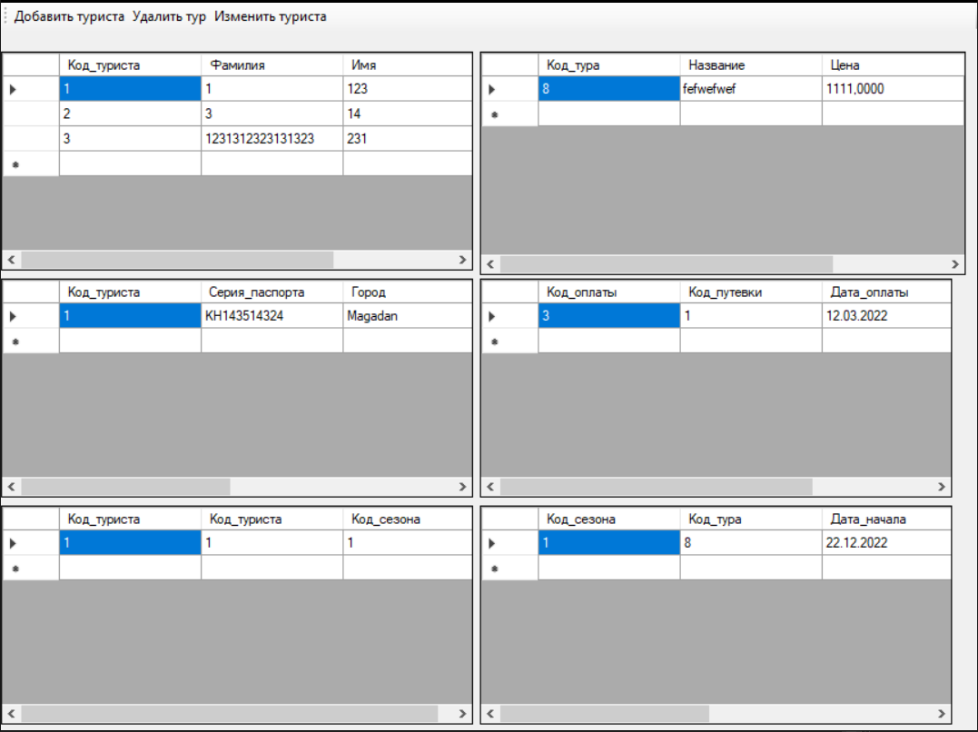

Рисунок 32.1 – Результат работы программы

Источник: собственная разработка